Stage 3 Physics Semester 2 Practical Exam

Name: ANSWERS (45 marks)

  - A student carried out an experiment with a long tube in a 5.00 x 10² mL measuring cylinder filled with water. He used a 384 Hz tuning fork and sounded it over the tube as he slowly removed the tube from the water. He found the sound volume increased at two lengths (the fundamental and the next harmonic). If he knew that the speed of sound in the pipe was 323 ms⁻¹, calculate the two lengths of pipe where the sound volume increased. (3 marks)

f_{f} = 384 Hz 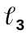 = =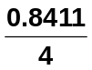 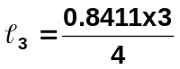
v = 323 m s⁻¹ = 0.210 m (1 mark) = 0.631 m (1 mark)

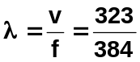
two lengths are 0.210 m and 0.631 m
λ = 0.8411 m
(1 mark)

  - Samantha was trying to find the speed of sound within an open tube. She set up the equipment shown and recorded the distances between maximum frequency readings using the CRO. She recorded her results in the table below.

Frequency  (Hz) | Distance between maximum freq. (cm) | Wavelength  (m) | Speed of sound (ms⁻¹)
200 | 84.5 | 1.69 | 338
500 | 68.0 | 1.36 | 680
800 | 21.2 | 0.424 | 339.2
1100 | 15.4 | 0.308 | 338.8

- Complete the wavelength column in the table showing your calculations for 200 Hz below.
(2 marks)
λ = 2 x
= 2 x 0.845
= 1.69 m

- Show your calculation for the speed of sound for 200 Hz below, then complete the last column in the table. (2 marks)
v = λf
= 1.69 x 200
= 338 m s⁻¹

- What value did Samantha get for the speed of sound ? (2 marks)
339 m s⁻¹ (if have 424 m s⁻¹, only 1 mark)
  - A student was performing some experiments on a standing wave. He collected the following data.

- The screen on a cathode ray oscilloscope showed four full waves.
- The dot producing the waves moved across the screen in 0.200 seconds.
- The wavelength was determined to be 0.500m
- The amplitude of the wave was 0.250 m

- Complete the following graphs (including scale) and clearly indicate the amplitude, period and wavelength. (4 marks)
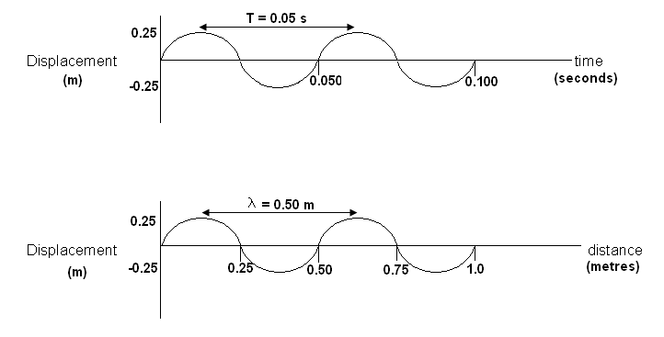 b. Calculate the velocity of the wave. (2 marks)

f = 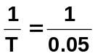 v = fλ
f = 20 Hz = 20 x 0.50
(1 mark) v = 10.0 m s⁻¹

- Sound is a mechanical wave.
- Are sound waves transverse or longitudinal waves? longitudinal (1 mark)
- Two transverse pulses travel along a spring (same amplitude and energy). If the first rebounds from a freed end with no loss of energy explain what you would see as it passes the second pulse which hasn’t reached the other end. Include a diagram. (3 marks)

Rebounding from free end means pulse returns on the same side
when pulses meet on same size of the spring, the amplitude would double.

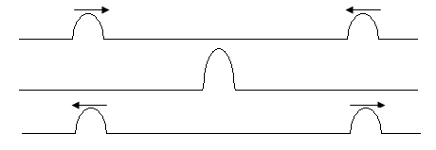
- You observed the light from a fluorescent tube and the light from the sun through a spectroscope.
  - Circle the correct answer. (2 marks)

    - The fluorescent tube emits a/an emission absorption spectrum
    - The sun emits a/an emission absorption spectrum
b. If you were to observe the spectrum of hydrogen gas emitted from a gas discharge tube it would appear as follows:

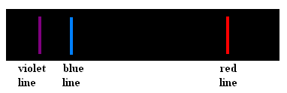

- What type of spectrum is this? line emission spectrum (1 mark)

- Explain how it is formed. (4 marks)
energy in tube gives energy to the electrons in the hydrogen atoms
electrons jump to higher levels.
on returning to ground level they emit photons of a range of frequencies
frequencies matching colours above are seem

- Read the information below then carry out the experiment.

Background Information:
The period of a pendulum can be found using the following equation:

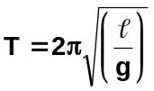 where T = period of oscillation (swing back and forth)
= length of the string
g = acceleration due to gravity; 9.8 ms⁻²

Hypothesis:
The period of oscillation of a pendulum is independent of the mass on the pendulum, therefore if the mass is increased, the period will remain constant within experimental error.

- Having been given the hypothesis, what were the variables for this experiment? (4 marks)
Dependent: ______time for one complete swing (oscillation)________ (1 mark)
Independent: ___mass on the end of the pendulum ________________ (1 mark)
Controls: 1. height mass released from
- length of string (not changed when mass added)
- reaction time of person (2 controls – 2 marks)
- Use the equipment provided to investigate if the hypothesis above is true by increasing the mass and measuring the period for each different mass, completing the table below. You need to ensure that all control variables are controlled.

Length of string: ________________ (Experimental accuracy and table completion 8 marks)

Mass | Time for 10 complete swings |  | Average for 10 swings | Period
Mass | Trial 1 | Trial 2 | Average for 10 swings | Period

This space has been left for any additional calculations you wish to do. This section can gain marks.

Student should show working for calculation of period, using length of string

This value should then be compared to experimental value from table within the discussion.

marks:
1. calculated value of T from length 2 marks
2. results in table consistent 2 marks
3. value of period has only two significant figures 1 mark
4. period correctly shown 2 marks
5. length of string clearly shown 1 mark

- Write a discussion and evaluation for this experiment. (7 marks)

Discussion – 4 marks

4 good discussion points including
- discussion of how the hypothesis relates to the results (1 mark)
- discussion of actual values – accuracy
including discussion of experimental vs calculated value (2 marks)
- concluding statement about results and experiment (1 mark)

Evaluation – 3 marks

Several sources of error discussed (2 marks)
with possible improvements (1 mark)

